Protocol for Measuring Neutralizing Antibodies Against HIV-1, SIV and SHIV Using a Luciferase Reporter Gene Assay in TZM-BL Cells

(Montefiori Lab)

July, 2005

INTRODUCTION:

This assay measures neutralization in TZM-bl cells as a function of a reduction in Tat-induced luciferase (Luc) reporter gene expression after a single round of infection (1). TZM-bl cells (also called JC57BL-13) may be obtained from the NIH AIDS Research and Reference Reagent Program (Cat. No. 8129). This is a HeLa cell clone that was engineered to express CD4 and CCR5 (2) and to contain integrated reporter genes for firefly luciferase and E. coli β-galactosidase under control of an HIV-1 LTR (3), permitting sensitive and accurate measurements of infection. The cells are highly permissive to infection by most strains of HIV, SIV and SHIV, including primary HIV-1 isolates and molecularly cloned pseudoviruses. DEAE dextran is used in the medium during neutralization assays to enhance infectivity. Expression of the reporter genes is induced in trans by viral Tat protein soon after infection. Luciferase activity is quantified by luminescence and is directly proportional to the number of infectious virus particles present in the initial inoculum (Fig. 1A). The assay is performed in 96-well culture plates for high throughput capacity. Use of a clonal cell population provides enhanced precision and uniformity.

We have validated this neutralization assay for single-cycle infection with either uncloned PBMC-grown viruses or molecularly cloned pseudoviruses produced by transfection in 293T cells. The HIV-1 protease inhibitor, indinavir, is added to the medium to prevent replication of uncloned PBMC viruses. Indinavir is not needed for assays with pseudoviruses, since these viruses are replication-defective by design.

References:

1. Montefiori, D.C. 2004. Evaluating neutralizing antibodies against HIV, SIV and SHIV in luciferase reporter gene assays. Current Protocols in Immunology, (Coligan, J.E., A.M. Kruisbeek, D.H. Margulies, E.M. Shevach, W. Strober, and R. Coico, eds.), John Wiley & Sons, 12.11.1-12.11.15.

2. Platt, E.J., K. Wehrly, S.E. Kuhmann, B. Chesebro, and D. Kabat. 1998. Effects of CCR5 and CD4 cell surface concentrations on infection by macrophage tropic isolates of human immunodeficiency virus type 1. J. Virol. 72:2855-2864.

3. Wei, X., J.M. Decker, H. Liu, Z. Zhang, R.B. Arani, J.M. Kilby, M.S. Saag, X. Wu, G.M. Shaw, and J.C. Kappes. 2002. Emergence of resistant human immunodeficiency virus type 1 in patients receiving fusion inhibitor (T-20) monotherapy. Antimicrob. Agents Chemother. 46:1896-1905.

HEAT-INACTIVATION OF SAMPLES

Clinical specimens may be serum or plasma, although serum is preferred. Anticoagulants in plasma are problematic in the assay, especially when heparin is used (some forms of heparin have potent and strain-specific antiviral activity). All anticoagulants (heparin, EDTA, ACD) are toxic to cells at plasma dilutions lower than 1:60. Samples should be heat-inactivated at 56ºC for 1 hour prior to assay. It is important to destroy complement activity by heat-inactivation. Complement in the serum of humans and nonhuman primates may enhance virus infection and mask neutralizing activity in cells that express complement receptors. In this regard, the expression of complement receptors on TZM-bl cells has not been thoroughly investigated. In other cases, complement activation may lead to lysis and inactivation of the virus. This latter phenomenon is a major concern for serum and plasma from small animals such as mice, guinea pigs and rabbits.

Samples should be mixed thoroughly by gentle agitation after thawing. Multiple freeze-thaw cycles should be avoided. Centrifuge the samples briefly after mixing to assure that no sample remains adhered to the inside cap or sides of the tube. Place tubes in a pre-calibrated 56ºC water bath, allowing the water level to reach the top of the sample volume but not touching the rim of the cap of the tube (for sterility purposes). Incubate for 1 hour. Remove and gently mix the sample to collect condensation that accumulated on the sides and top of the tube. Centrifuge briefly to pellet any insoluble materials. Store at 4ºC in cases where assays are to be performed within 2 weeks. Store at -80ºC in cases where assays will be delayed for >2 weeks.

CELL CULTURE

TZM-bl is an adherent cell line that we maintain in T-75 culture flasks. Complete growth medium (GM) consists of D-MEM supplemented with 10% fetal bovine serum (FBS, heat-inactivated) and gentamicin (50 μg/ml). Cell monolayers are disrupted and removed by treatment with trypsin/EDTA:

Trypsin-EDTA Treatment for Disruption of TZM-bl Cell Monolayers:

TZM-bl is an adherent cell line that is maintained in T-75 culture flasks. Cell monolayers are disrupted and removed by treatment with trypsin/EDTA at confluency when splitting cells for routine maintenance and when preparing cells for assay.

1. Decant the culture medium and remove residual serum by rinsing monolayers with 6 ml of sterile PBS.

2. Slowly add 2.5 ml of an 0.25% Trypin-EDTA solution to cover the cell monolayer. Incubate at room temp for 30-45 seconds. Decant the trypsin solution and incubate at 37ºC for 4 minutes. Do not agitate the cells by hitting or shaking the flask while waiting for the cells to detach.

3. Add 10 ml of GM and suspend the cells by gentle pipet action. Count cells.

4. Seed new T-75 culture flasks with approximately 10⁶ cells in 15 ml of GM. Cultures are incubated at 37ºC in a 5% CO₂/95% air environment. Cells should be split approximately every 3 days.

VIRUS STOCKS

Stocks of uncloned viruses may be produced in either PBMC or T cell lines. Pseudoviruses may be produced by transfection in an appropriate cell type, such as 293T cells. All virus stocks should be made cell free by low speed centrifugation and filtration (0.45-micron) and stored at -80ºC in GM containing 20% FBS.

TCID50 DETERMINATION

It is necessary to determine the TCID50 of each virus stock in a single-cycle infection assay (2-day incubation) in TZM-bl cells prior to performing neutralization assays. We use a cut-off value of 2.5-times background RLU when quantifying positive infection in TCID50 assays.

We have observed that too much virus in the neutralization assay can result in strong virus-induced cytopathic effects that interfere with accurate measurements. Most virus stocks must be diluted at least 10-fold to avoid cell-killing. A standard inoculum of 200 TCID50 was chosen for the neutralization assay to minimize virus-induced cytopathic effects while maintaining an ability to measure a 2-log reduction in virus infectivity. It should be noted that different strains vary significantly in their cytopathicity. It may be necessary to use a lower TCID50 in the neutralization assay for highly cytopathic strains of virus. As shown in Fig. 1B, greater sensitivity is achieved in the neutralization assay at lower input TCID50 doses but overall this difference is less than 3-fold between 50 and 1,000 input TCID50 in most cases. Virus-induced cytopathic effects may be monitored by visual inspection of syncytium formation under light microscopy. Cytopthic effects may also be observed as reductions in luminescence at high virus doses in the TCID50 assay (Fig. 1A).

NEUTRALIZING ANTIBODY ASSAY PROTOCOL

NOTE 1: All incubations are performed in a humidified 37ºC, 5% CO₂ incubator unless otherwise specified.

NOTE 2: Assays with replication-competent viruses are performed in DEAE-GM containing 1 μM indinavir.

1. Using the format of a 96-well flat-bottom culture plate as illustrated Template A (Fig. 2), place 150 μl of GM in all wells of column 1 (cell control). Place 100 μl in all wells of columns 2-11 (column 2 will be the virus control). Place an additional 40 μl in all wells of columns 3-12, row H (to receive test samples).

2. Add 11 μl of test sample to each well in columns 3 & 4, row H. Add 11 μl of a second test sample to each well in columns 5 & 6, row H. Add 11 μl of a third test sample to each well in columns 7 & 8, row H. Add 11 μl of a fourth test sample to each well in columns 9 & 10, row H. Add 11 μl of a fifth test sample to each well in columns 11 & 12, row H. Mix the samples in row H and transfer 50 μl to row G. Repeat the transfer and dilution of samples through row A (these are serial 3-fold dilutions). After final transfer and mixing is complete, discard 50 μl from the wells in columns 3-12, row A into a waste container of disinfectant.

This format is designed to measure neutralizing antibody titers in the range of 1:20 to 1:43,740. Appropriate adjustments may be made to test a different range of dilutions (see "Standard Dilution Charts"). This format is designed to assay 5 samples in duplicate wells at each serum dilution per plate. Adjustments may be made to test a larger number of samples per plate. For example, 10 samples may be assayed at 4 dilutions in duplicate per plate by simply dividing the plate in half (Fig. 2, Template B). Alternatively, samples may be screened at a single dilution (Fig. 2, Template C). This latter option is advantageous when neutralizing activity is to be determined against a large number of strains. Due to possible nonspecific activity at low sample dilutions, it is recommended that corresponding pre-immune samples be included when performing screening assays.

A positive control with a known neutralization titer against the target virus should be included on at least one plate in series each time assays are performed. Also, at least one negative control sample is strongly advised. Ideally, negative controls consist of corresponding pre-immune or pre-infection samples from either test animals or study subjects. In the case of clinical vaccine trials, a sufficient number of post-inoculation samples from placebo recipients may serve to provide adequate information on negative control values.

3. Thaw the required number of vials of virus by placing in an ambient temperature water bath. When completely thawed, dilute the virus in GM to achieve a concentration of 4,000 TCID₅₀/ml.

Cell-free stocks of virus should be prepared in advance and cryopreserved in working aliquots of approximately 1 ml.

4. Dispense 50 μl of cell-free virus (200 TCID₅₀) to all wells in columns 2-12, rows A through H. Mix by pipet action after each transfer. Rinse pipet tips in a reagent reservoir containing 40 ml sterile PBS between each transfer to avoid carry-over.

5. Cover plates and incubate for 1 hour.

6. Prepare a suspension of TZM-bl cells (trypsinize aproximately 10-15 minutes prior to use) at a density of 1 x 10⁵ cells/ml in GM containing DEAE dextran (37.5 μg/ml). Dispense 100 μl of cell suspension (10,000 cells per well) to each well in columns 1-12, rows A though H. Rinse pipet tips in a reagent reservoir filled with sterile PBS between each transfer to avoid carry-over. The final concentration of DEAE dextran is 15 μg/ml.

7. Cover plates and incubate for 48 hours.

8. Remove 150 μl of culture medium from each well, leaving approximately 100 μl. Dispense 100 μl of Bright Glo™ Reagent to each well. Incubate at room temperature for 2 minutes to allow complete cell lysis. Mix by pipet action (at least two strokes) and transfer 150 μl to a corresponding 96-well black plate. Read the plate immediately in a luminometer.

9. Percent neutralization is determined by calculating the difference in average RLU between test wells (cells + serum sample + virus) and cell control wells (cells only, column 1), dividing this result by the difference in average RLU between virus control (cell + virus, column 2) and cell control wells (column 1), subtracting from 1 and multiplying by 100. Neutralizing antibody titers are expressed as the reciprocal of the serum dilution required to reduce RLU by 50%.

ANALYZING AND PRINTING RESULTS

The "Luminescence" macro calculates the percent neutralization provided by each serum dilution. Our luminometer is interfaced with a dedicated computer in the BSL-3 laboratory and linked electronically to a data analysis computer in our general office area. Each raw data file is assigned an identification number (ID) corresponding to the date, plate number and assay number. For example, the ID for assays performed on February 4, 2002 of plate #3 would be: 0204023. Transfer raw data electronically to the data analysis computer. This avoids having to transfer computer diskettes between BSL-3 and non-BSL3 laboratory areas. Analyze and print the data using the Microsoft Excel macro. The data print-out must include: i) experiment number, ii) protocol number, iii) cells used in the assay, iv) length of incubation in days, v) name, lot number and dilution of the virus stock used, vi) ID, visit number and bleed date of each sample and vii) signature of technician who performed the assay.

REAGENT PREPARATION

Bright Glo™ Reagent:

Reconstitute one vial of lyophylized Luciferase Assay Substrate (part #E263B) with 400 ml of Luciferase Assay Buffer (part # E264B). After the substrate is dissolved completely, store in 10 ml aliquots at -70ºC for up to 1 month. Thaw aliquots in an ambient temperature water bath immediately before use. Note: The substrate will be diluted 4x what is recommended by the manufacturer. This dilution has performed in an acceptable manner for the assay.
Figure 1. Linearity of infection and neutralization in TZM-bl cells.
A
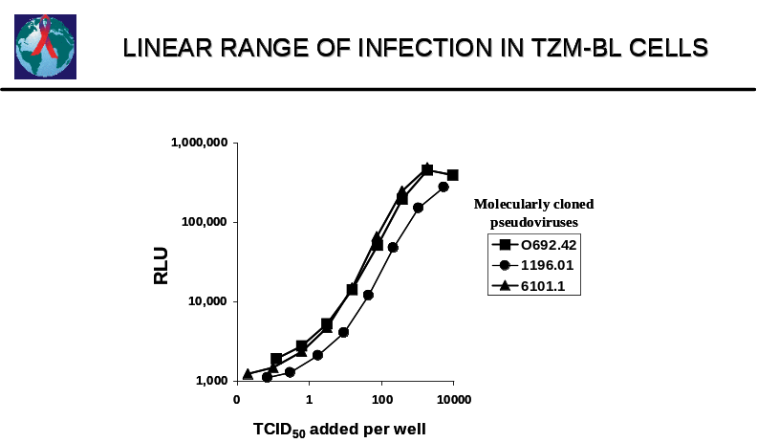

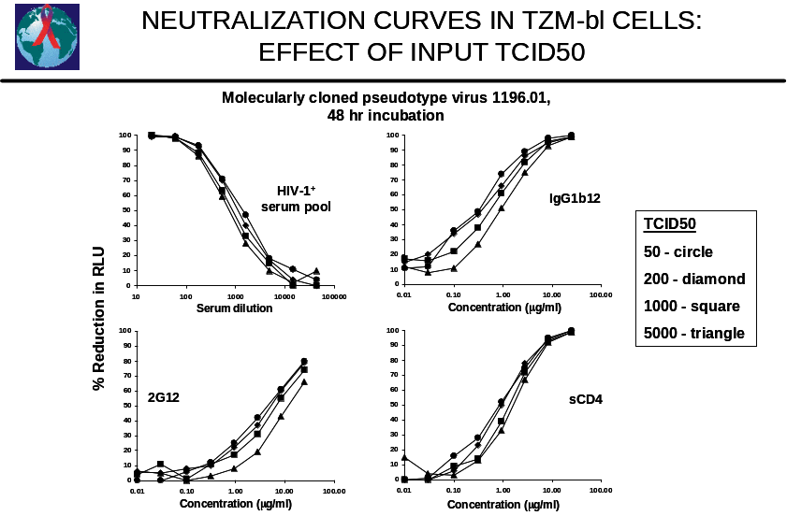
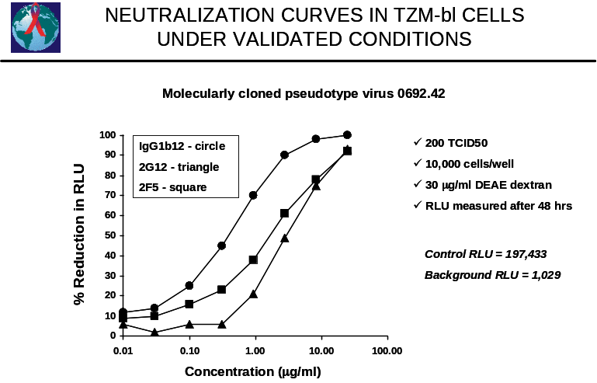
B
C
Figure 2. Various templates for neutralization assays

Template A
 | 1 | 2 | 3 | 4 | 5 | 6 | 7 | 8 | 9 | 10 | 11 | 12
A | CC | VC | Dil 8 | Dil 8 | Dil 8 | Dil 8 | Dil 8 | Dil 8 | Dil 8 | Dil 8 | Dil 8 | Dil 8
B | CC | VC | Dil 7 | Dil 7 | Dil 7 | Dil 7 | Dil 7 | Dil 7 | Dil 7 | Dil 7 | Dil 7 | Dil 7
C | CC | VC | Dil 6 | Dil 6 | Dil 6 | Dil 6 | Dil 6 | Dil 6 | Dil 6 | Dil 6 | Dil 6 | Dil 6
D | CC | VC | Dil 5 | Dil 5 | Dil 5 | Dil 5 | Dil 5 | Dil 5 | Dil 5 | Dil 5 | Dil 5 | Dil 5
E | CC | VC | Dil 4 | Dil 4 | Dil 4 | Dil 4 | Dil 4 | Dil 4 | Dil 4 | Dil 4 | Dil 4 | Dil 4
F | CC | VC | Dil 3 | Dil 3 | Dil 3 | Dil 3 | Dil 3 | Dil 3 | Dil 3 | Dil 3 | Dil 3 | Dil 3
G | CC | VC | Dil 2 | Dil 2 | Dil 2 | Dil 2 | Dil 2 | Dil 2 | Dil 2 | Dil 2 | Dil 2 | Dil 2
H | CC | VC | Dil 1 | Dil 1 | Dil 1 | Dil 1 | Dil 1 | Dil 1 | Dil 1 | Dil 1 | Dil 1 | Dil 1

Sample 1 Sample 2 Sample 3 Sample 4 Sample 5

Template B
 | 1 | 2 | 3 | 4 | 5 | 6 | 7 | 8 | 9 | 10 | 11 | 12
A | CC | VC | Dil 4 | Dil 4 | Dil 4 | Dil 4 | Dil 4 | Dil 4 | Dil 4 | Dil 4 | Dil 4 | Dil 4
B | CC | VC | Dil 3 | Dil 3 | Dil 3 | Dil 3 | Dil 3 | Dil 3 | Dil 3 | Dil 3 | Dil 3 | Dil 3
C | CC | VC | Dil 2 | Dil 2 | Dil 2 | Dil 2 | Dil 2 | Dil 2 | Dil 2 | Dil 2 | Dil 2 | Dil 2
D | CC | VC | Dil 1 | Dil 1 | Dil 1 | Dil 1 | Dil 1 | Dil 1 | Dil 1 | Dil 1 | Dil 1 | Dil 1
E | CC | VC | Dil 4 | Dil 4 | Dil 4 | Dil 4 | Dil 4 | Dil 4 | Dil 4 | Dil 4 | Dil 4 | Dil 4
F | CC | VC | Dil 3 | Dil 3 | Dil 3 | Dil 3 | Dil 3 | Dil 3 | Dil 3 | Dil 3 | Dil 3 | Dil 3
G | CC | VC | Dil 2 | Dil 2 | Dil 2 | Dil 2 | Dil 2 | Dil 2 | Dil 2 | Dil 2 | Dil 2 | Dil 2
H | CC | VC | Dil 1 | Dil 1 | Dil 1 | Dil 1 | Dil 1 | Dil 1 | Dil 1 | Dil 1 | Dil 1 | Dil 1

Samples 1 & 2 Samples 3 & 4 Samples 5 & 6 Samples 7 & 8 Samples 9 & 10

Template C
 | 1 | 2 | 3 | 4 | 5 | 6 | 7 | 8 | 9 | 10 | 11 | 12
A | CC | VC | S#4  Post | S#4  Post | S#4  Post | S#8  Post | S#8  Post | S#8  Post | S#12  Post | S#12  Post | S#12  Post | BLK
B | CC | VC | S#4  Pre | S#4  Pre | S#4  Pre | S#8  Pre | S#8  Pre | S#8  Pre | S#12  Pre | S#12  Pre | S#12  Pre | BLK
C | CC | VC | S#3  Post | S#3  Post | S#3  Post | S#7  Post | S#7  Post | S#7  Post | S#11  Post | S#11  Post | S#11  Post | BLK
D | CC | VC | S#3  Pre | S#3  Pre | S#3  Pre | S#7  Pre | S#7  Pre | S#7  Pre | S#11  Pre | S#11  Pre | S#11  Pre | BLK
E | CC | VC | S#2  Post | S#2  Post | S#2  Post | S#6  Post | S#6  Post | S#6  Post | S#10  Post | S#10  Post | S#10  Post | BLK
F | CC | VC | S#2  Pre | S#2  Pre | S#2  Pre | S#6  Pre | S#6  Pre | S#6  Pre | S#10  Pre | S#10  Pre | S#10  Pre | BLK
G | CC | VC | S#1  Post | S#1  Post | S#1  Post | S#5  Post | S#5  Post | S#5  Post | S#9  Post | S#9  Post | S#9  Post | BLK
H | CC | VC | S#1  Pre | S#1  Pre | S#1  Pre | S#5  Pre | S#5  Pre | S#5  Pre | S#9  Pre | S#9  Pre | S#9  Pre | BLK

Figure 2. Three optional templates for measuring either the titer of neutralizing antibodies or the potency of neutralization at a single dilution. Format A: Template for measuring the titer of neutralizating antibodies using 5 samples per plate. Format B: Template for measuring the titer of neutralizating antibodies using 10 samples per plate. Format C: Template for screening samples at a single dilution. CC, cell control wells (cells only); VC, virus control wells (virus and cells but no serum sample are added here); BLK, blank wells; S#, sample number; Pre, pre-immune sample; Post, post-immune sample.

STANDARD DILUTION CHART FOR 2-FOLD DILUTIONS

DESIRED START
DILUTION GM VOLUME (μl) SAMPLE VOLUME (μl)
________________ ________________ ____________________

1:5 40 60
1:10 70 30
1:15 80 20
1:20 85 15
1:25 90 12
1:30 90 10
1:50 95 6

First place 100 μl of growth medium in all wells of columns 3-11. Add the extra amount of growth medium listed above, then add the desired sample volume to the first 3 wells and do 2-fold dilutions (i.e., serial transfers of 100 μl).

STANDARD DILUTION CHART FOR 3-FOLD DILUTIONS

DESIRED START
DILUTION GM VOLUME (μl) SAMPLE VOLUME (μl)
________________ ________________ ____________________

1:5 5 45
1:8 25 28
1:10 30 22
1:15 35 15
1:20 40 11
1:24 50 10
1:45 45 5

First place 100 μl of growth medium in all wells of columns 3-11. Add the extra amount of growth medium listed above, then add the desired sample volume to the first 3 wells and do 3-fold dilutions (i.e., serial transfers of 50 μl).
EQUIPMENT, SUPPLIES AND REAGENTS

Item | Source | Cat. No. | Unit | Price
Fetal Bovine Serum, Hyclone, heat-inact. | Duke CCC | AME 16299 | 500 ml | $138.20
D-MEM (4.5 g/l D-glucose, 110 mg/ml sodium pyruvate, L-glutamine) | Invitrogen | 11995-065 | 500 ml | 15.10
Gentamicin | Sigma | G1272 | 10 ml | 8.45
Indinavir sulfate | NIH ARRRP | 8145 | 20 mg | 0.00
Trypsin-EDTA (0.25% trypsin, 1 mM EDTA tetrasodium salt) | Invitrogen | 25200-056 | 100 ml | 7.95
DEAE-dextran, hydrochloride, avg. mol. wt. 500,000 | Sigma | D-9885 | 10 g | 24.60
Microliter Pipet Tips | ICN | 77-988-H2 | 10 bxs | 66.30
Sterile Disposable Reagent Reservoirs | Falcon/VWR | 4870 | 200/CS | 62.93
1 ml Sterile Disposable Pipets | Falcon/VWR | 357521 | 1000/CS | 124.10
5 ml Sterile Disposable Pipets | Falcon/VWR | 357543 | 200/CS | 31.64
10 ml Sterile Disposable Pipets | Falcon/VWR | 357551 | 200/CS | 32.53
25 ml Sterile Disposable Pipets | Falcon/VWR | 357535 | 200/CS | 74.74
Sterile Disposable Culture Flasks, T-25 | Costar/VWR | 3056 | 200/CS | 139.52
Sterile Disposable Culture Flasks, T-75 | Costar/VWR | 3375 | 100/CS | 75.52
96-Well Flat-Bottom Culture Plates | Costar/VWR | 3595 | 50/CS | 68.82
96-Well Black Solid Plates | Costar/VWR | 3915 | 100/CS | 260.30
Bright-Glo Luciferase Assay System | Promega | E2650 | 1 L | 4,785.00
Bright Glow Luciferase Assay Buffer Contact: megan.gray@promega.com | Promega | E264X | 100 ml | 67.00
Surgical Gowns (Trimax) | Allegiance | 39010 | CS | 217.82
Latex Gloves, Perry Surgical | Allegiance | 22537-570 | 100/bx | 15.29
Shoe Covers | Allegiance | AT01-3701 | CS | 44.16
Biohazard Autoclave Bags | VWR | 14220-52 | 200/CS | 126.18
Major Equipment:
Luminometer, Victor for FI and LUM | PerkinElmer Life Sciences | 1420-032 | Each | 15,999.00

